**Nagios3 Installation :**

1. Launch new instance (ubuntu,Red hat..etc)
2. Install tasksel in your os (***apt-get install tasksel***)
3. Then type ***tasksel*** in terminal (give Space bar -----> Enter)
4. Give ms-sql password (like :ramesh,confirm password ramesh)
5. Check the apache2 server is started (***service apachew2 status***)
6. ***apt-get install nagios3***
7. press tab -> ok tab -> ok
8. Give password ***ramesh (Default nagios3 “nagiosadmin”)***
9. Nagiios3 installation completed check if the software is installation (***copy the public ip like (123.456.56.67/nagios3)***

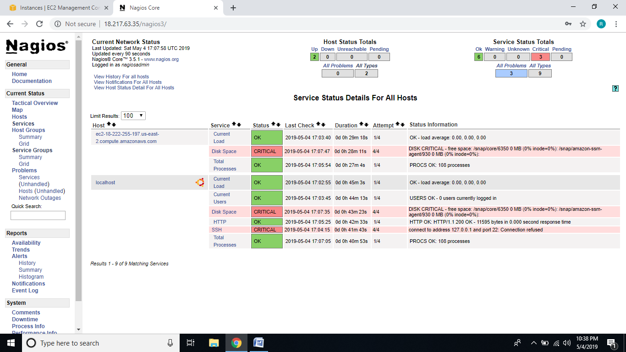

**How to add New Node in Nagios3:**

1. First we need to check the node ip is pingable or not
2. Open the nagios3 server terminal go to (***cd /etc/nagios3/config.d***)
3. Copy the local-nagios.cfg with Node private DNS IP address(***cp local-nagios.cfg private DNS Name.cfg(don’t forget give extinctions with .cfg“***)
4. Open the copied config file

Define host{

Host_nane public dns ip

Alias public ip

Address private ip

}

1. Replace all where local host to public dns ip
2. Check if it is working or not by using below command

***naigos3 –v /etc/nagios3/nagios.cfg***

1. Then restart the nagios3 (***service nagios3 restart***)